Asia-China-Coin-Spade-Round Foot-Mould

晋阳圆足布,The "JinYang"Round-Foot Spade-shape Coin."晋阳" place of the Zhao Nation in the warring states period,Now it is the TaiYuan City,ShanXi Province.It was used in the Zhao Nation,late warring sates period. 11.5CM/4.53Inches, width 4.5CM/1.77Inches,

钱范,Coin Pattern.Used to make coin.The ancient chinese coin mostly made of Bronze.The goverment need this coin pattern first.So,coin pattern is more rare and precious than coin itself.

This collection is a very rare Spade-shape Coin Pattern.

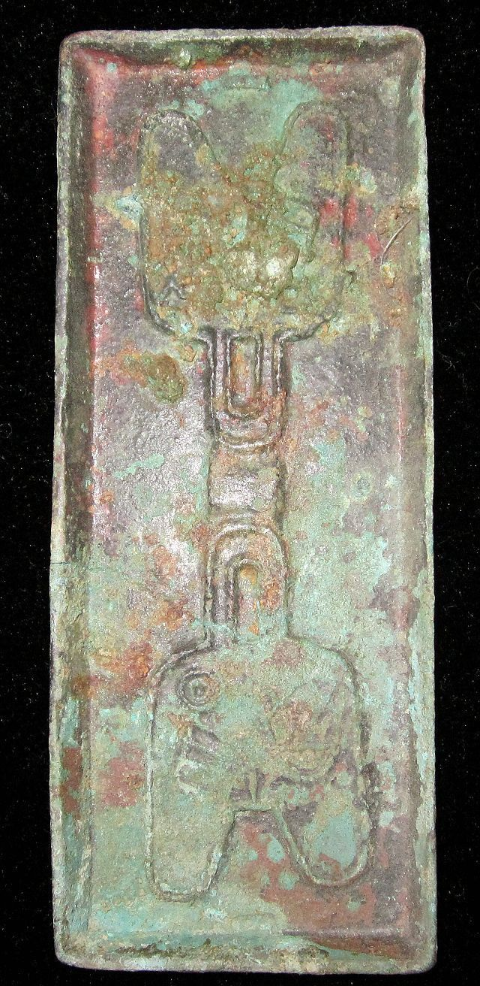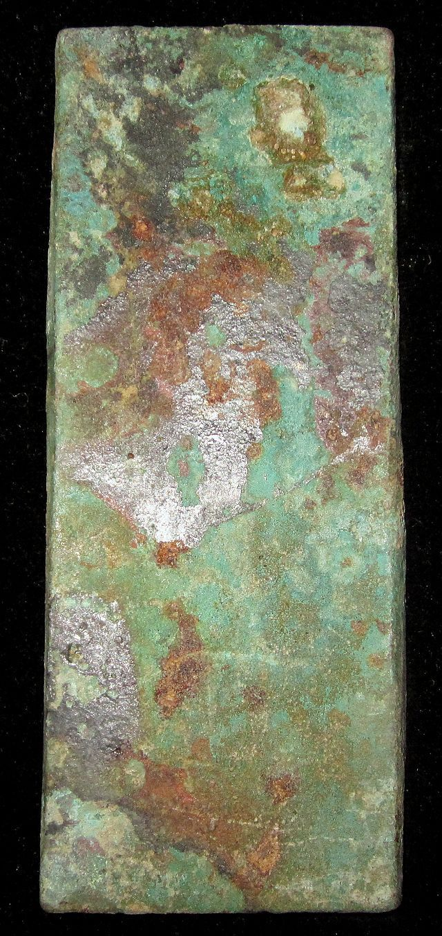

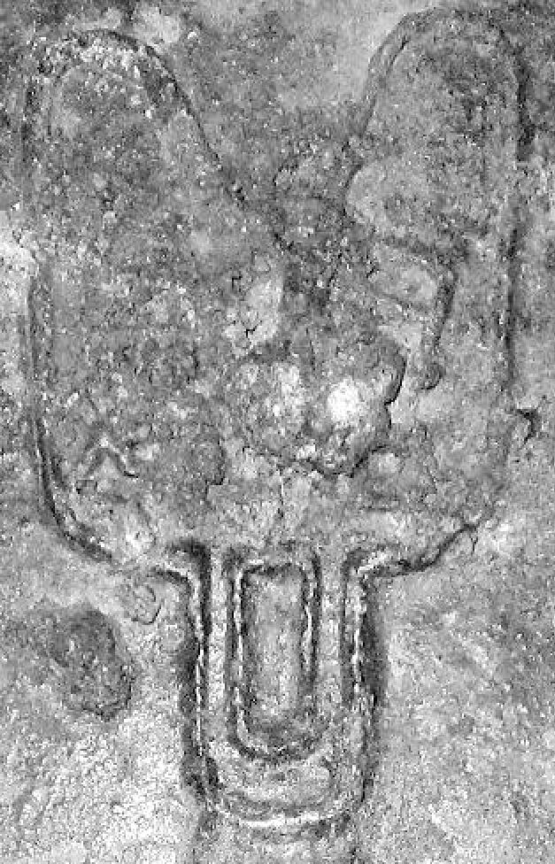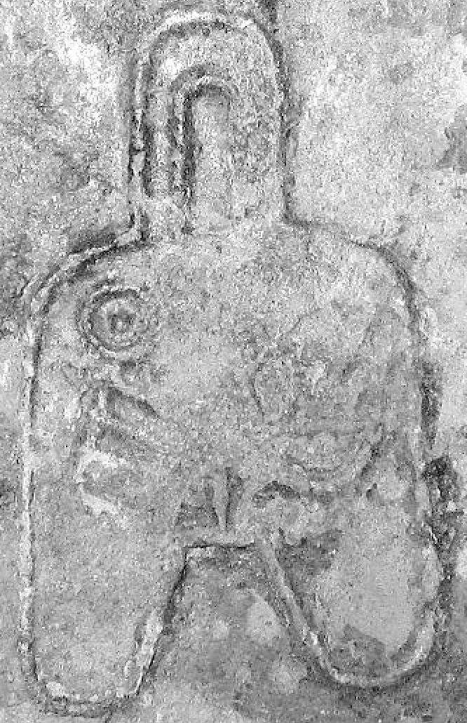

Order details Printer friendly page

Sold by

[bcculture](http://myworld.ebay.com/bcculture) ( [81](http://feedback.ebay.com/ws/eBayISAPI.dll?ViewFeedback&userid=bcculture)  )

+ Show additional actions

Delivery package 1 of 1

Estimated delivery Thursday, Jan 16, 2014 - Thursday, Feb 13, 2014

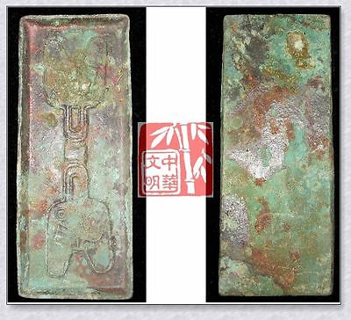

[WARRINGSTATESPERIOD ZHAO NATION MINT MONEY MODEL BRONZE SPADE COIN PATTERN晋阳圆足布](http://www.ebay.com/itm/251391146316)

Item price

$79.99

Quantity

1

Item number

251391146316

Shipping service

Economy Shipping from outside US

[Leave feedback](http://feedback.ebay.com/ws/eBayISAPI.dll?LeaveFeedbackShow&useridfrom=802-867&useridto=bcculture&item=251391146316&transactid=1359873001015) [Contact seller](http://contact.ebay.com/ws/eBayISAPI.dll?FindAnswers&frm=3998&iid=251391146316&redirect=0&requested=bcculture) [Return item](http://return.ebay.com/ws/eBayISAPI.dll?ResolveReturn&eventName=viewSelectedItem&TransactionId=1359873001015&ItemId=251391146316)

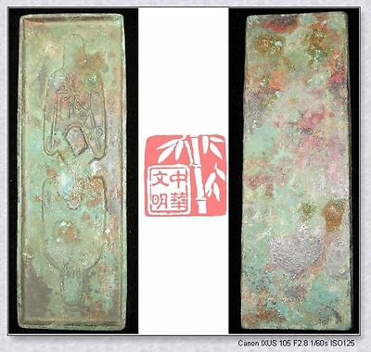

[WARRINGSTATESPERIOD ZHAO CITY MINT MONEY MODEL BRONZE SPADE COIN PATTERN离石三十五圆足布](http://www.ebay.com/itm/251391204570)

Item price

$79.99

Quantity

1

Item number

251391204570

Shipping service

Economy Shipping from outside US

[Leave feedback](http://feedback.ebay.com/ws/eBayISAPI.dll?LeaveFeedbackShow&useridfrom=802-867&useridto=bcculture&item=251391204570&transactid=1359907380015) [Contact seller](http://contact.ebay.com/ws/eBayISAPI.dll?FindAnswers&frm=3998&iid=251391204570&redirect=0&requested=bcculture) [Return item](http://return.ebay.com/ws/eBayISAPI.dll?ResolveReturn&eventName=viewSelectedItem&TransactionId=1359907380015&ItemId=251391204570)

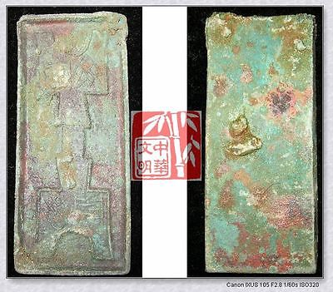

[WarringStatesPeriod WEI CITY MINT MONEY MODEL BRONZE SPADE COIN PATTERN阴晋桥足布RARE](http://www.ebay.com/itm/251412498472)

Item price

$49.99

Quantity

1

Item number

251412498472

Shipping service

Economy Shipping from outside US

[Leave feedback](http://feedback.ebay.com/ws/eBayISAPI.dll?LeaveFeedbackShow&useridfrom=802-867&useridto=bcculture&item=251412498472&transactid=1359874723015) [Contact seller](http://contact.ebay.com/ws/eBayISAPI.dll?FindAnswers&frm=3998&iid=251412498472&redirect=0&requested=bcculture) [Return item](http://return.ebay.com/ws/eBayISAPI.dll?ResolveReturn&eventName=viewSelectedItem&TransactionId=1359874723015&ItemId=251412498472)

### Shipping address

Ralph J Coffman Jr  
149 Atlantic Ave   
Swampscott MA 01907-2427  
United States

Phone number  
781 584 7091

### Order total

Subtotal $209.97

Shipping $95.00

Shipping discount -$6.00

#### Total

## $298.97

[View PayPal transaction](http://payments.ebay.com/ws1/eBayISAPI.dll?IntermediateResolutionInfo&itemid=0&transId=0&pn=UnifiedCheckoutSummaryRedirect2PP&qs=itemid%3D0%26transId%3D0%26buyerorseller%3D0%26)

### Order information

Order placed on  
Saturday, Dec 28, 2013

Having a problem with this purchase?  
[Resolve problem](http://res.ebay.com/ws/eBayISAPI.dll?ResolutionCenter)

Payment method   
PayPal

Payment date  
Saturday, Dec 28, 2013